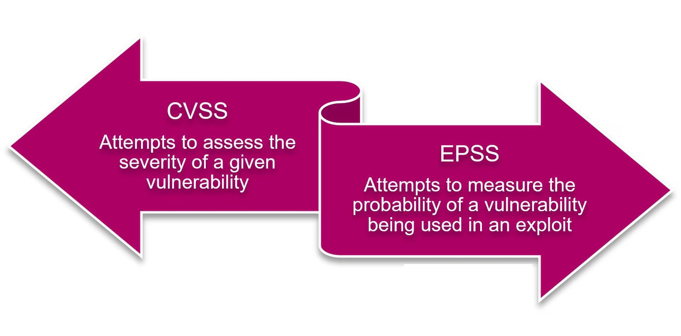

Presented by
Professor Dr. Mohammed Shafiul Alam Khan IIT, DU

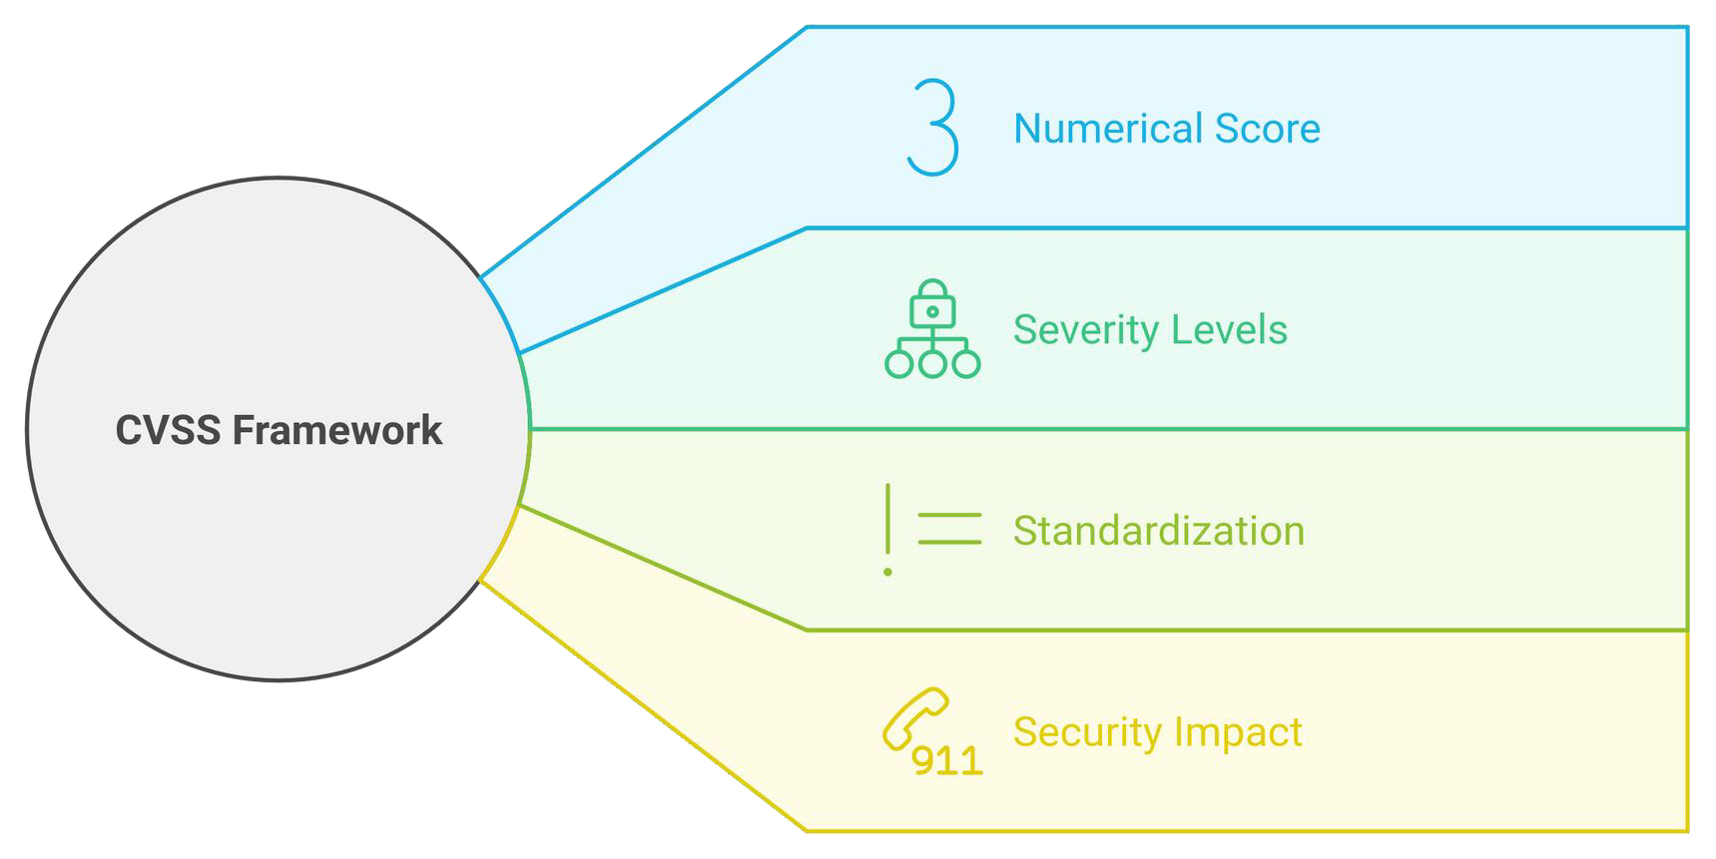

CVSS (Common Vulnerability Scoring System)
- A standardized framework that measures the severity of security vulnerabilities
- Provides a standardized method for rating vulnerabilities based on their impact.
- Assigns a numerical score between 0 and 10 to each vulnerability, with higher scores indicating more severe issues

How Does It Work?

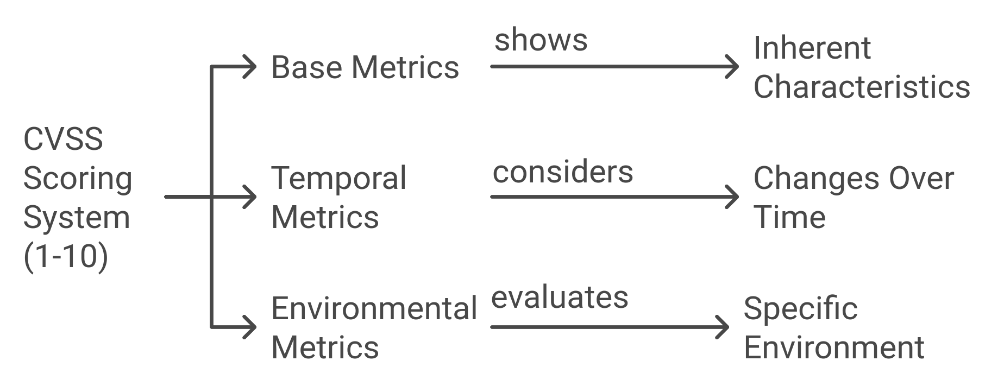

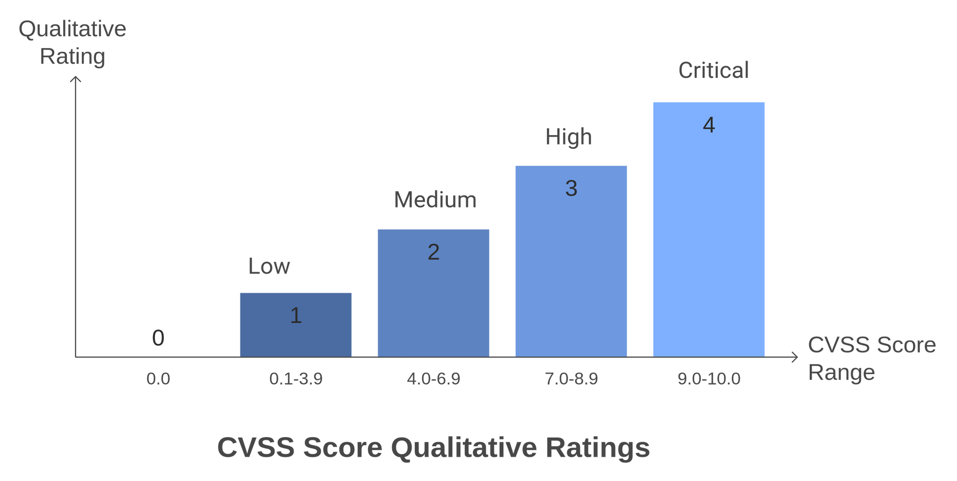CVSS Score

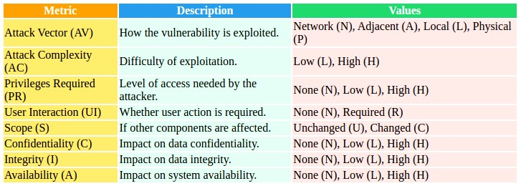
Base Metrics
DESCRIBES CORE unchanging CHARACTERISTICS OF THE VULNERABILITY.
INCLUDES

CVSS PRIMARY METRIC GROUPS

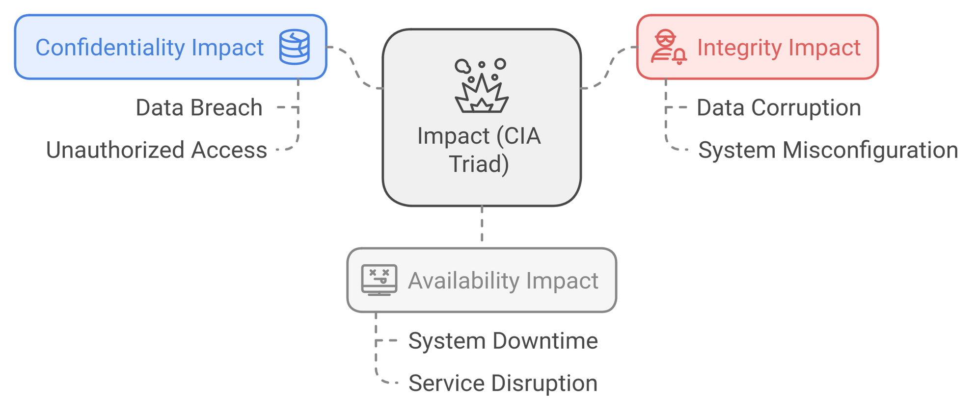Base Metrics
IMPACT

CVSS PRIMARY METRIC GROUPS

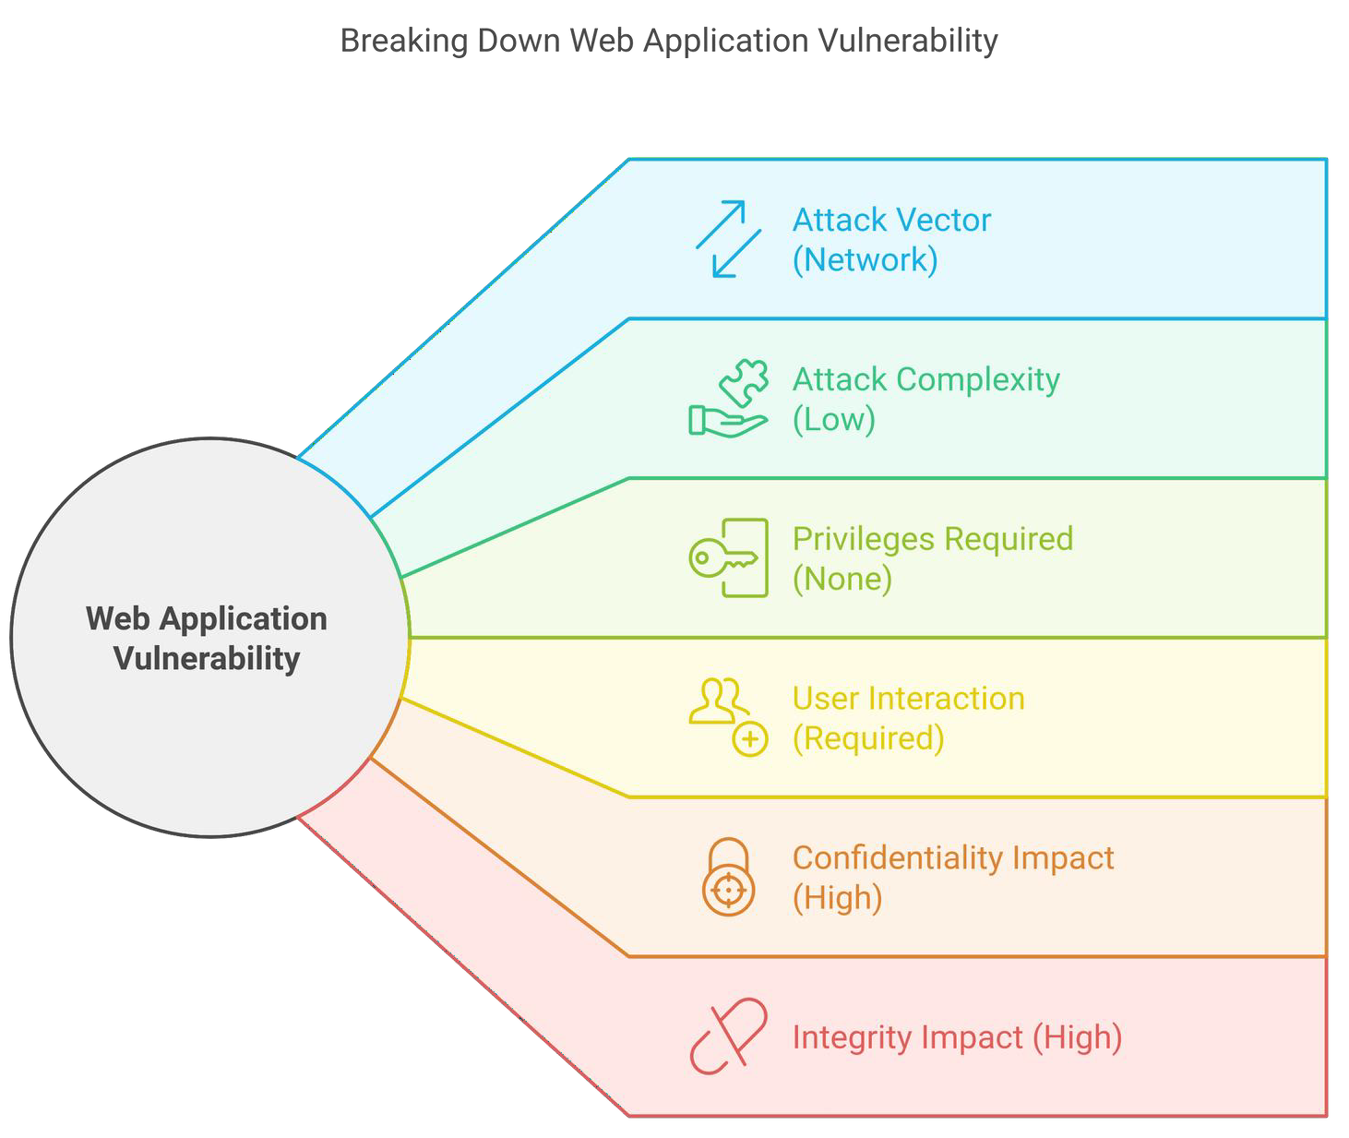Base Metrics
Example

CVSS PRIMARY METRIC GROUPS

Temporal Metric
CVSS PRIMARY METRIC GROUPS
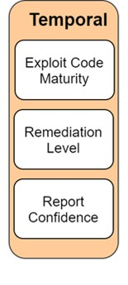
Describe things that might change after the vulnerability is discovered, i.e. Exploit availability.

Exploit Code Maturity (E): Measures exploit tool sophistication.
- Values: Not Defined, Unproven, Proof-of-Concept, Functional, High
Remediation Level (RL): Indicates fix availability.
- Values: Not Defined, Unavailable, Workaround, Temporary Fix, Official Fix
Report Confidence (RC): Reflects certainty of vulnerability.
- Values: Not Defined, Unknown, Reasonable, Confirmed

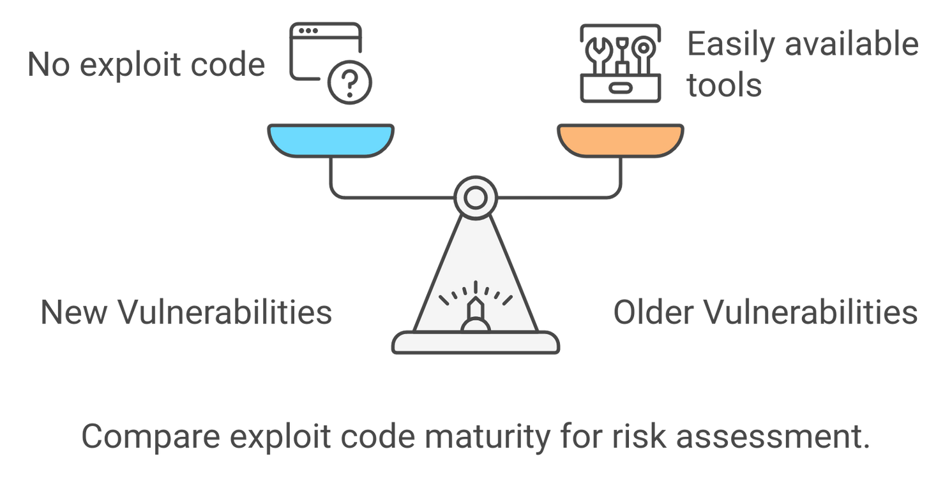
Temporal MEXePLtOrITicCOsDE MATURITY
A
new
bug
might
have no exploit code yet, but older bugs
might have easily available tools to exploit them.
CVSS PRIMARY METRIC GROUPS

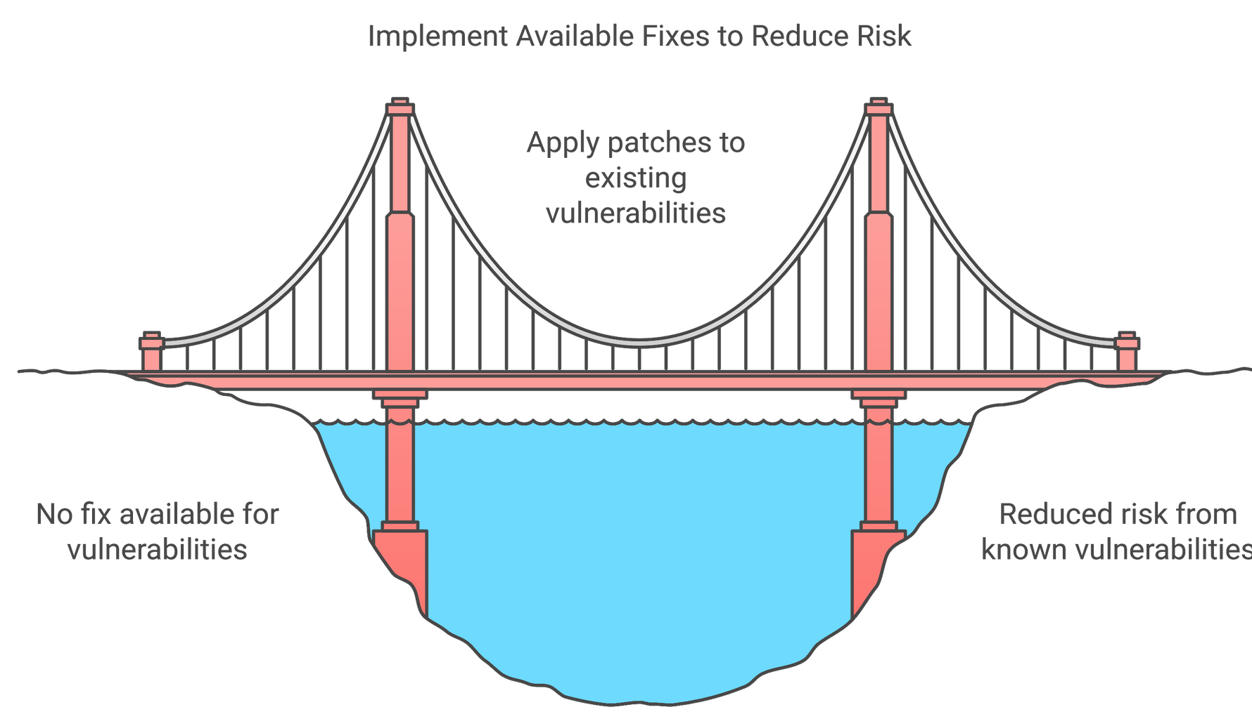Temporal MREeMEtDrIiAcTIsON LEVEL
CVSS PRIMARY METRIC GROUPS

If a patch is ready, the risk might go down.

CVSS PRIMARY METRIC GROUPS

Environmental

MThesee tarre ispcecsific to one’s environment, meaning the same vulnerability might be
more severe for one organization than another.

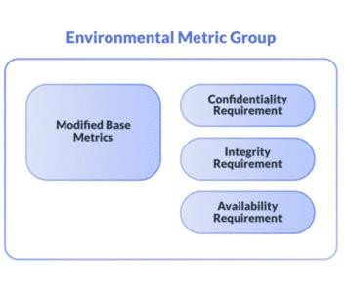
Modified Base Metrics
- Customizes base metrics for specific organizational contexts.

Security Requirements (CR, IR, AR)
- Weigh the importance of Confidentiality, Integrity, and Availability.
- Values: Low, Medium, High.

CVSS PRIMARY METRIC GROUPS

Environmental
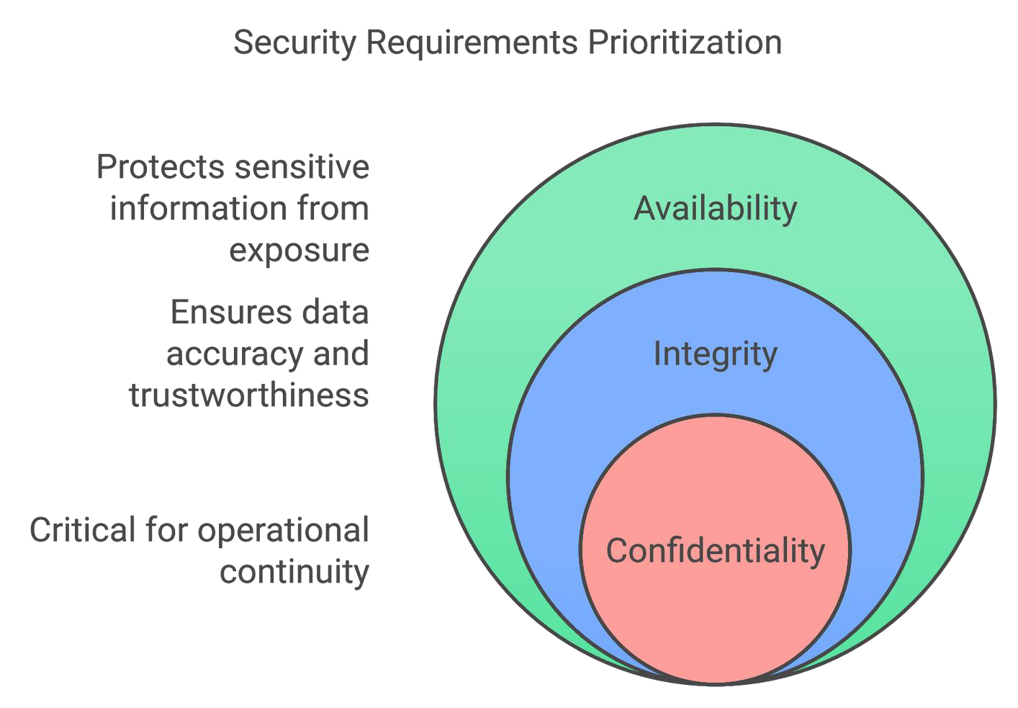
SMeceutrirtyicRsequirements

A
might
hospital
Availability
rank
higher because downtime could endanger lives.

CVSS PRIMARY METRIC GROUPS

Environmental
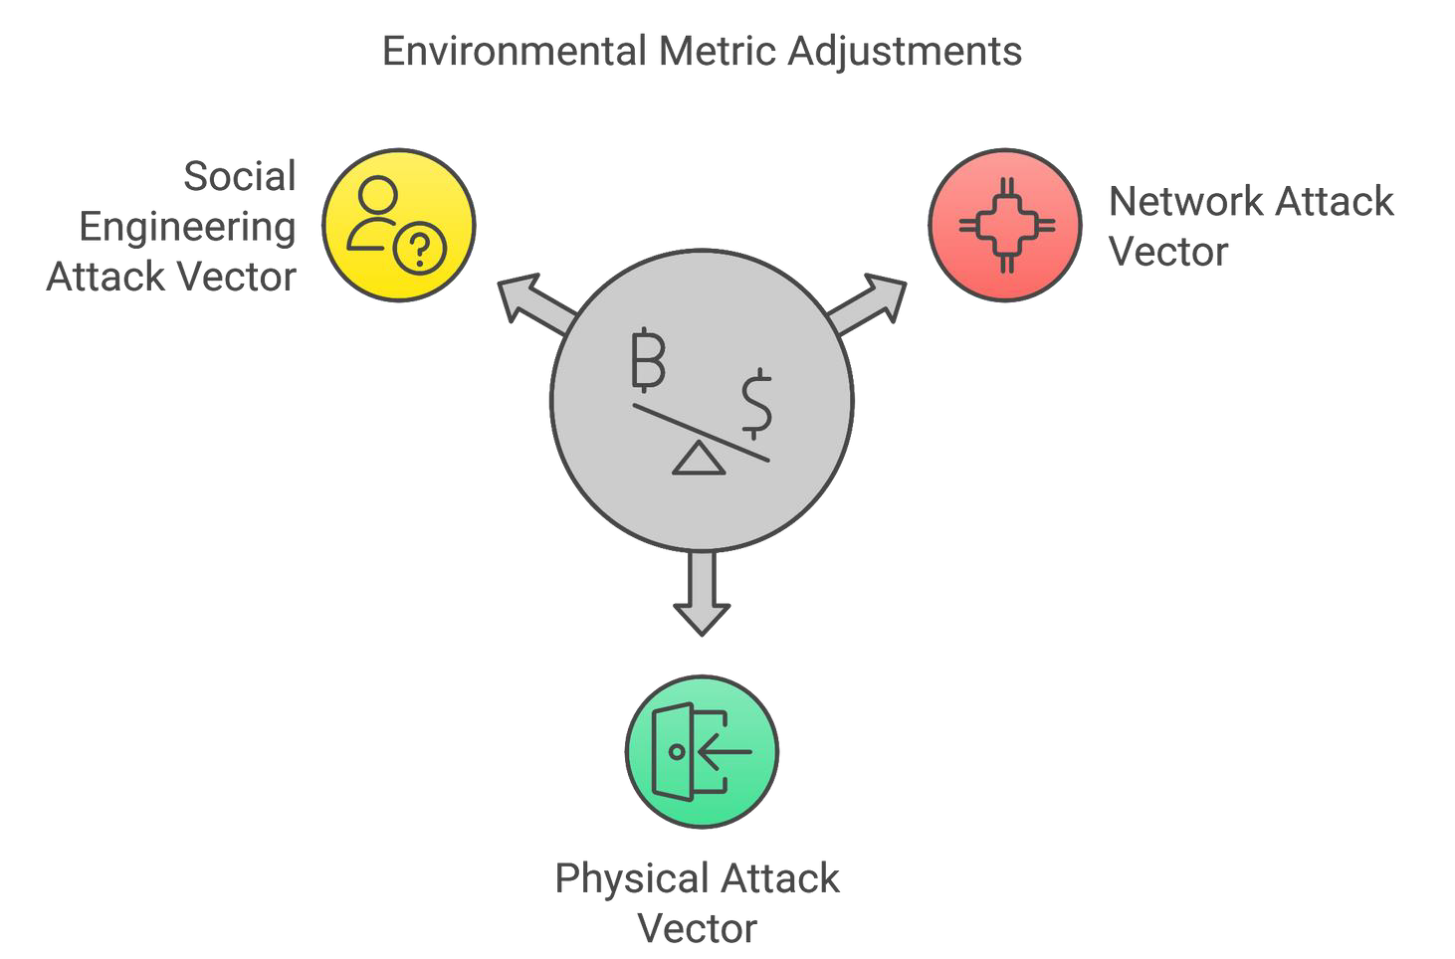
MMoeditfireidcBsase Metrics
If
you
have
no
external
access, Network
internet
the attack
vector
apply.
might
not

CVSS PRIMARY METRIC GROUPS

Activities in CVSS
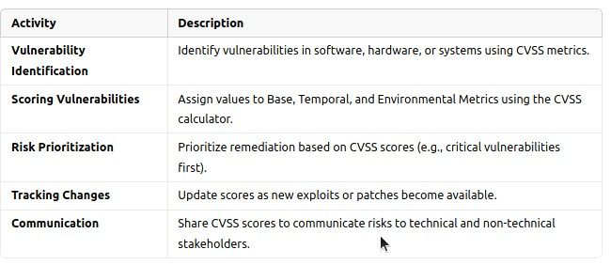

CVSS PRIMARY METRIC GROUPS

Example of a CVSS
Base Metrics:
- AV (Attack Vector): Network (N)
- AC (Attack Complexity): Low (L)
- PR (Privileges Required): None (N)
- UI (User Interaction): None (N)
- C (Confidentiality Impact): High (H)
- I (Integrity Impact): High (H)
- A (Availability Impact): High (H)

Environmental Metrics:
- Confidentiality Importance: High for critical servers ⚠️
Final Score: 9.8 (Critical) 🔴

Temporal Metrics:
- Exploit Available: ✅
- Remediation Level: Official fix

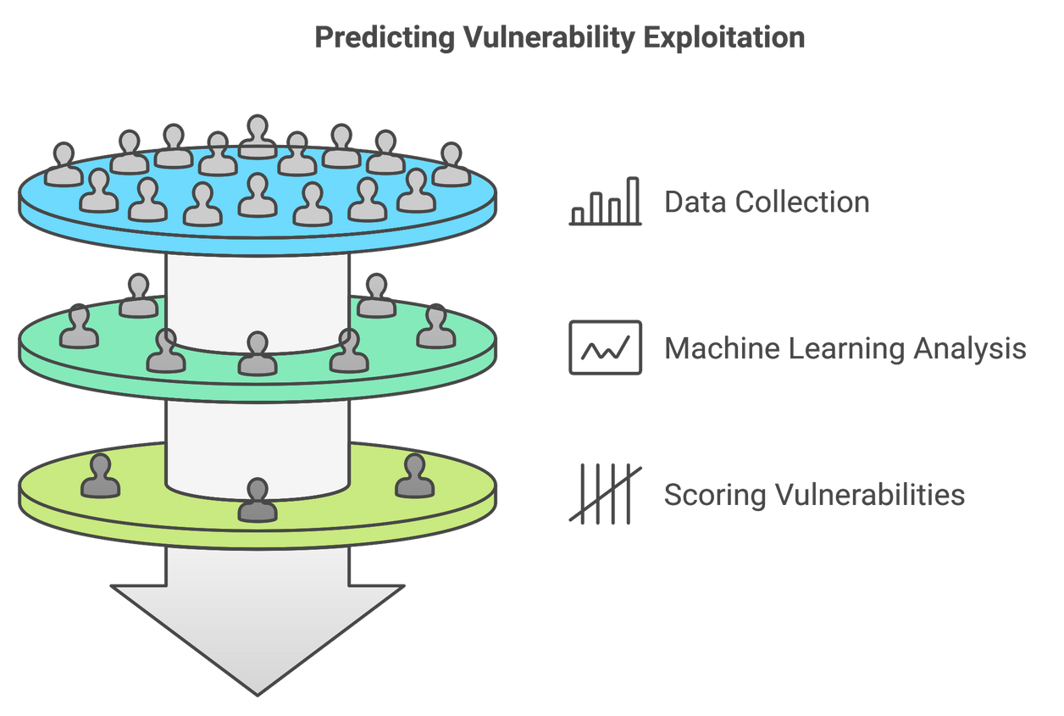

EPSS

- EPSS is a scoring system that predicts the likelihood of a vulnerability being exploited in the near future. It uses historical data and machine learning models to estimate, and hence Dynamic and Data-Driven.
- Complement CVSS
- Developed by FIRST (Forum of Incident Response and Security Teams).

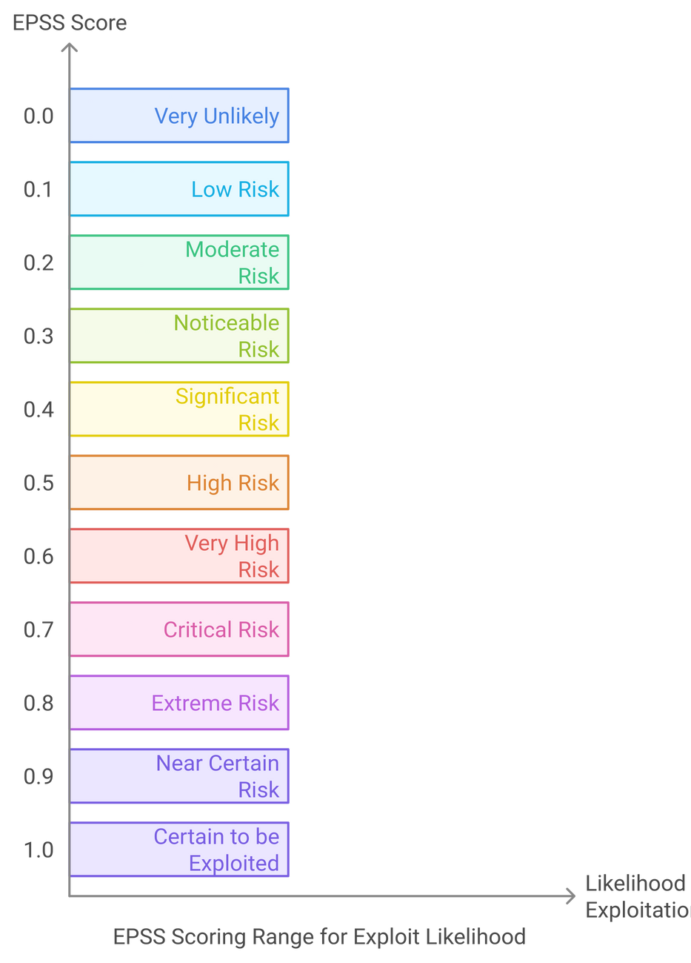
EPSS

Scoring Range
The EPSS score ranges from 0.0 (very unlikely to be exploited) to 1.0 (certain to be exploited).

Benefits

- Prioritization: Focus on high-risk vulnerabilities
- Efficiency: Avoid wasting resources on lower-risk vulnerabilities
- Proactivity: Stay prepared for any potential attacks

How It Works
- U ses infor m ation fr om v ar iou s data sou r ces like v u lner ability database, ex ploit
EPSS

Data ML
Collection

Scoring

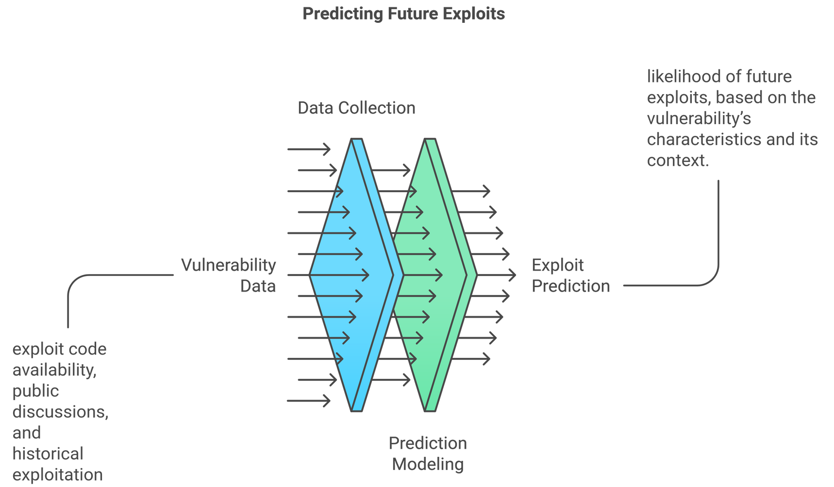repositor ies, real- w or ld attack data.
- Scor es pr obability of ex ploitation fr om 0 to 1 u sing M L and statistical m odels.
- Changes assigned scor es as new data becom es av ailable.

EPSS

Factors Considered in EPSS
- Exploitation complexity
- Attack vector
- Confidentiality, integrity, and availability impact
CVSS Attributes
- Previous vulnerability exploitation trend
- Current threat landscape
Historical Data
- Information from databases like NVD (National Vulnerability Database)
- Likelihood of discovery of the vulnerability
Public Vulnerability Database

EPSS

Why EPSS?

  - Vulnerabilities are constantly discovered.
  - Not all
vulnerabilities are exploited.
  - Focuses efforts on
the highest risk.
96% of the vulnerabilities scored with EPSS score of
less than 0.1, were neither exploited or prioritized for remediation (True Negative (TN)). 1.8% were both exploited and prioritized for remediation (TP).

Source: https://orca.security/resources/blog/epss- scoring-system-explained/

EPSS

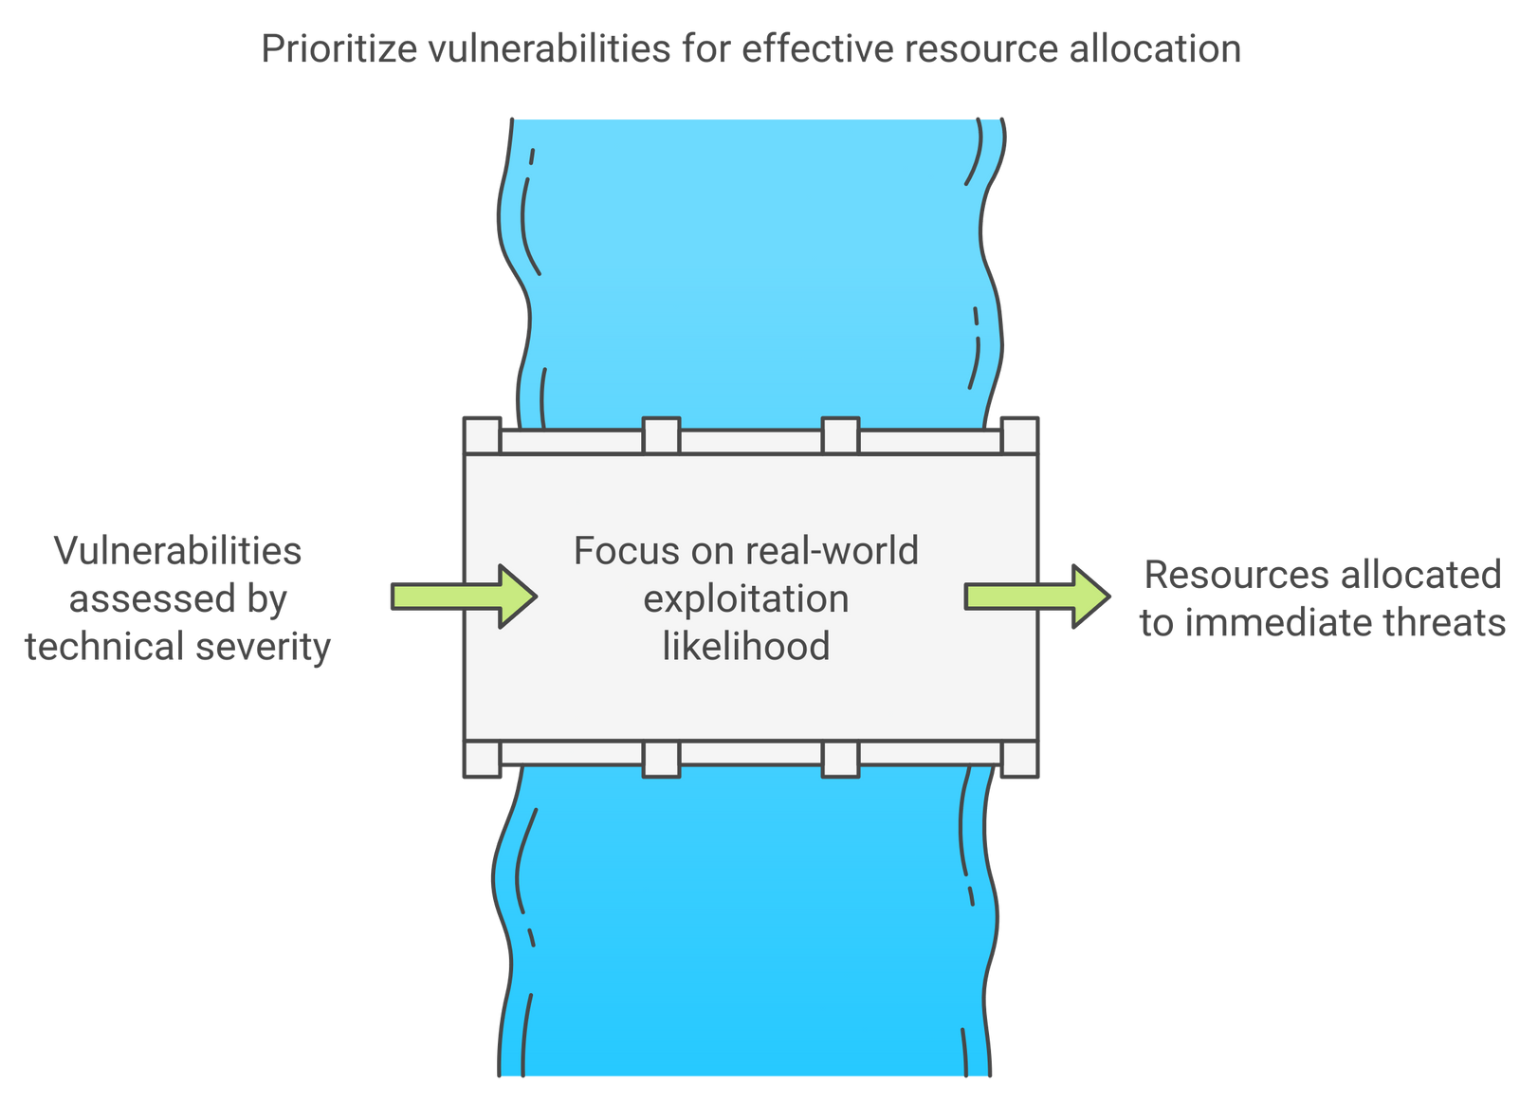
Challenges Addressed

- Overwhelming Number of Vulnerabilities
- Ineffective Prioritization
- Resource Constraints

EPSS

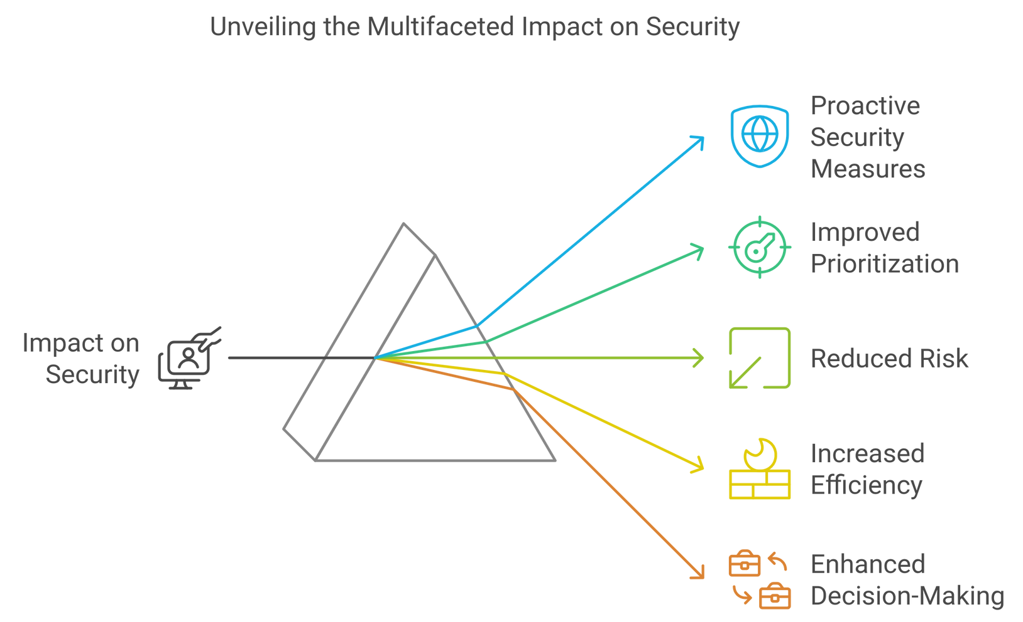
Impacts

EPSS

How to Use

EPAcSceSss?

EPSS scores through the FIRST website.

https://www.first.org/epss/
- Integrate EPSS into vulnerability management workflow.
- Use EPSS to complement CVSS and other security tools.

EPSS in Action
  - A vulnerability with CVSS 9 but EPSS 0.05 Action: lower priority
  - A vulnerability with CVSS 7 but EPSS 0.9 Action: higher priority

EPSS vs
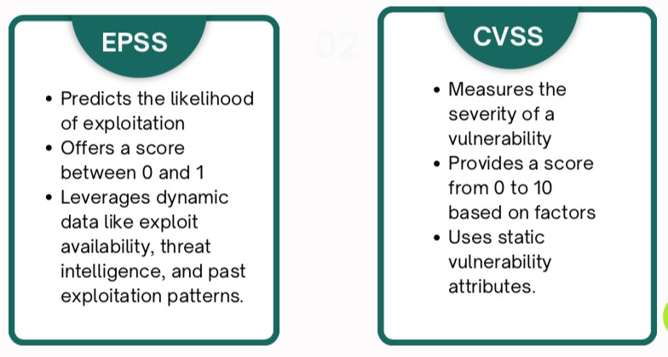
CVSS



THANK YOU!

